Key Findings and Trends
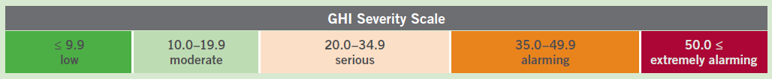
Scores among the 118 countries in the report varied widely. Scores of 9.9 or lower denote low hunger; scores between 35.0 and 49.9 denote alarming hunger. This year no countries hit the threshold of 50, which signifies extremely alarming hunger levels. Yet, it is impossible to know exactly how severe hunger is in some of the world’s poorest countries that lack GHI scores.

Interactive Global Map

Progress in Reducing Hunger
- 29% Decrease in GHI scores across the developing world since 2000
- No countries in the “extremely alarming” category for second year in a row
- The 2016 GHI score for the developing world is 21.3, which is still considered “serious.”
- 22 countries have reduced their GHI scores by 50% or more since 2000
- 70 countries have reduced their GHI scores by 25%-49.9% since 2000

Not reaching zero hunger
- The current rate of reducing hunger will leave South Asia and Africa south of the Sahara with GHI scores near the divide between “moderate and serious” hunger—falling far short of the goal to reach Zero Hunger by 2030.
- Conservative projections find more than 45 countries – including India, Pakistan, Haiti, Yemen, and Afghanistan - will not even reach “low” hunger levels by 2030.

Persistent High Hunger Scores
- Despite the progress made, levels of hunger remain “serious” or “alarming” in 50 of the 118 countries with GHI scores.
- Africa South of the Sahara and South Asia have the highest levels of hunger, at 30.1 and 29.0, respectively
- 20 countries have populations in which at least one quarter of the population is undernourished
- Highest scores in the report
  - Central African Republic – 46.1
  - Chad – 44.3
  - Zambia – 39.0
  - Haiti – 36.9
  - Madagascar – 35.4
  - Yemen – 35.0
- Thirteen countries in the report have insufficient data to calculate GHI scores, yet based on the existing data and reliable reports, 10 of these countries have hunger levels that are cause for significant concern. In Africa South of the Sahara these include: Burundi, Comoros, the Democratic Republic of Congo, Eritrea, Somalia, South Sudan, and Sudan.

- Regional GHI scores:
  - Africa South of the Sahara: 30.1
  - South Asia: 29.0
  - East & Southeast Asia: 12.8
  - Near East & North Africa: 11.7
  - Eastern Europe & Commonwealth of Independent States: 8.3
  - Latin America & Caribbean: 7.8

Global Hunger Index Background
The 2016 Global Hunger Index (GHI) is calculated for 118 countries for which data are available for four indicators:
- the percentage of the population that is undernourished,
- the percentage of children under age five who suffer from wasting (low weight for height),
- the percentage of children under age five who suffer from stunting (low height for age), and
- the percentage of children who die before the age of five (child mortality).

How do you interpret a GHI score?
An increase in a country's GHI score indicates that the hunger situation is worsening, while a decrease in the score indicates improvement in the country's hunger situation.

Could GHI scores be calculated for all countries?
No, due to missing or unavailable data, GHI scores could not be calculated for all countries.

More information can be found at: http://www.ifpri.org/topic/global-hunger-index

